RSVP launches online tech training for seniors
- By RSVP
- Dec 16, 2020

In order to improve the sense of isolation many seniors are feeling during the pandemic, RSVP, King of Prussia, has launched the Senior Technology Training Program to provide online skills to seniors who have access to computers or smart devices but don’t know how to use them well.
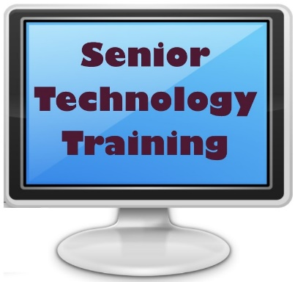
“The program will give older adults the ability to remain engaged in their community and continue to ‘age well’ during these months when they are separated from their friends and families,” said RSVP Executive Director Michele Moll. “It will help them have access to their social network and support system, preventing loneliness.
“In addition, many people are avoiding needed medical care because they do not feel comfortable navigating the process. Now, seniors will be equipped with the knowledge to schedule telehealth appointments and more.”
A pilot team of five RSVP volunteers is being trained and will begin working virtually later this month with an initial group of five to 10 senior tech students.
“We envision the online lessons for seniors to occur during an eight-week period, with two one-hour sessions per week,” said project manager Scherri Roberts. “Our five tech mentors include a retired information technology trainer, a web developer and a student. Everybody brings something different to the table.”
RSVP is seeking additional tech mentors, seniors who want training and corporate sponsors for the program.
“Volunteers who would like to be trainers should be comfortable using computers, apps, the internet and mobile devices,” Roberts said. “They will need approximately three hours per week and a computer with a camera and microphone.”
Seniors interested in receiving the training must be at least age 55, have a computer, tablet or smartphone and have an email address and a basic knowledge of their device.
“We want to get them to a comfort level using the technology to enhance their sense of connection and well-being, and perhaps prepare them for their own virtual volunteer activity down the road,” Roberts said.
The mentors will use lessons developed by the national nonprofit educational organization Oasis. Through its institute in St. Louis, Oasis began developing courses for seniors more than 20 years ago. RSVP's tech training subjects will include use of the internet, email, social media, the video communications program Zoom and will teach seniors how to order groceries online.
“RSVP is actively seeking corporate partners to sponsor the Senior Technology Training Program,” Moll said.
Sponsors would help fund the program. Some sponsors might also provide tutors as a community service. Sponsor packages begin at $1,000 and include logo placements and alignment with RSVP’s well-regarded community programs.
Seniors interested in receiving tech training should complete the application at https://tinyurl.com/seniortech-Form.
You can volunteer as a tech mentor at https://mon-ami.typeform.com/to/N3MK42Qi.
For more information about the program, contact Kathy Stocker at kathys@rsvpmc.org or 610-834-1040, ext. 123
Corporate and other potential sponsors should contact Lydia Messinger at lydiam@rsvpmc.org or 610-834-1040, ext. 124.
RSVP improves the lives of vulnerable populations in the Greater Philadelphia area and beyond with programs focusing on education and wellness which utilize a dedicated pool of more than 1,200 volunteers. To learn more visit www.rsvpmc.org.

RSVP’s Senior Technology Training program manager, Scherri Roberts

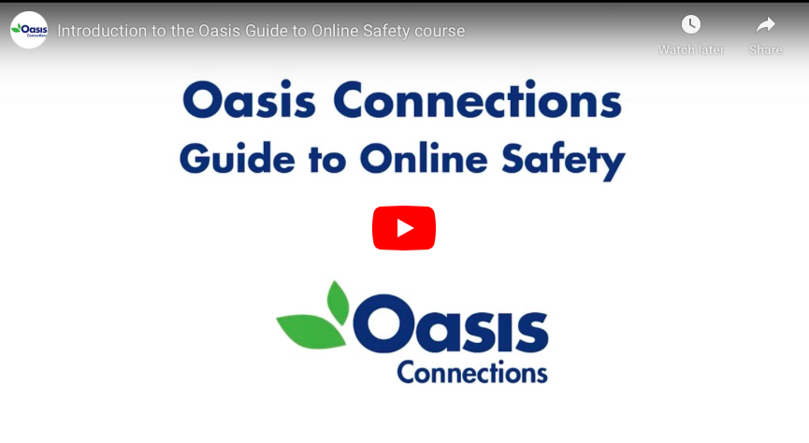
Oasis Training Screen Shot

